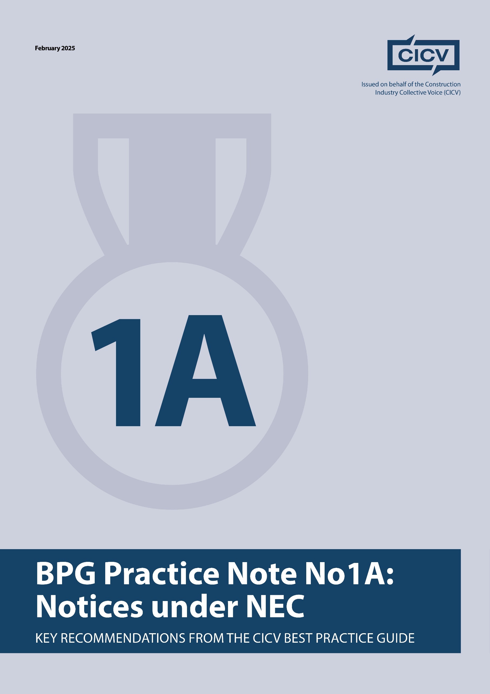

**CICV Best Practice Guide – Practice Note 1A: Notices under NEC**

This Practice Note is a supplement to Practice Note 1 ‘Notice’, aimed at highlighting key specific notice provisions under NEC3 & 4 Engineering and Construction Contracts (‘ECC’) and the NEC3 & 4 Engineering and Construction Subcontract (‘ECS’).

**Specific Situations Requirement Notices**

Contractors and subcontractors should be aware that generally, NEC contracts contain notice provisions in respect of the following situations:

* Compensation Events.
* Early Warning.
* Defects.
* Ambiguities and inconsistencies.
* Illegal and impossible requirements.
* Prevention.
* Termination.

A brief overview these provision is as follows:

**NEC3 & 4 (ECC)**

Compensation Events

* The *Project Manager* notifies the *Contractor* of compensation events arising from an instruction, the issue of a certificate, the changing of an earlier decision, or a correction of an assumption (cl.61.1).
* The *Contractor* notifies the *Project Manager* of an event the *Contractor* believes to be a compensation event that has not been notified by the *Project Manager* (cl.61.3).
* The *Project Manager* notifies the *Contractor* if the *Project Manager* decides that an event notified by the *Contractor* is not a compensation event (cl.61.4).
* When requesting a quotation from the *Contractor*, the *Project Manager* notifies the *Contractor* if the *Project Manager* decides the *Contractor* failed to issue an early warning notice (cl.61.5).
* If the effects of a compensation event cannot be reasonably ascertained with certainty, then, in an instruction to provide quotations, the *Project Manager* states any assumptions made by the *Project Manager* concerning the effects of a compensation event (cl.61.6).

Early Warning

* The *Project Manager* and the *Contractor* notify each other as soon as they become aware of any matter which could increase the total of the Prices, delay Completion, delay meeting a Key Date, or impair the performance of the *works* in use (cl.16.1[NEC3] / cl.15.1[NEC4]).

Defects

* Up to the *defects date*, the *Supervisor* and the *Contractor* notify each other of Defects as soon as they find them (cl.42.2[NEC3] / cl.43.2[NEC4]).

Ambiguities and Inconsistencies

* The *Project Manager* or the *Contractor* notify each other as soon as they become aware of any ambiguity or inconsistency in or between the contract documents (cl.17.1).

Illegal and Impossible Requirements

* The *Contractor* notifies the *Project Manager* if the *Contractor* believes the Works Information [NEC3] (or ‘Scope’ as per the NEC4) requires him to do anything illegal or impossible (cl.18.1[NEC3] / cl.17.2[NEC4]).

Prevention

* If an event occurs, which neither Party could prevent, that stops the *Contractor* from completing the *works* by the date shown on the Accepted Programme, the *Project Manager* notifies (instructs) the *Contractor* on how the event is to be dealt with (cl.19.1).

Termination

* If either Party wishes to terminate the *Contractor’s* obligation to Provide the Works, the Party wishing to terminate notifies the reason to the *Project Manager* and the other party (cl.90.1).

**NEC3 & 4 (ECS)**

Compensation Events

* The *Contractor* notifies the *Subcontractor* of compensation events arising from an instruction, the issue of a certificate, the changing of an earlier decision, or a correction of an assumption (cl.61.1).
* The *Subcontractor* notifies the *Contractor* of an event the *Subcontractor* believes to be a compensation event that has not been notified by the *Contractor* (cl.61.3).
* The *Contractor* notifies the *Subcontractor* if the *Contractor* decides that an event notified by the *Subcontractor* is not a compensation event (cl.61.4).
* When requesting a quotation from the *Subcontractor*, the *Contractor* notifies the *Subcontractor* if the *Contractor* decides the *Subcontractor* failed to issue an early warning notice (cl.61.5).
* If the effects of a compensation event cannot be reasonably ascertained with certainty, then, in an instruction to provide quotations, the *Contractor* states any assumptions made by the *Contractor* concerning the effects of a compensation event (cl.61.6).

Early Warning

* The *Contractor* and the *Subcontractor* notify each other as soon as they become aware of any matter which could increase the total of the Prices, delay Completion, delay meeting a Key Date, or impair the performance of the *works* in use (cl.16.1[NEC3] / cl.15.1[NEC4]).

Defects

* Up to the *defects date*, the *Subcontractor* and the *Contractor* notify each other of Defects as soon as they find them (cl.42.2[NEC3] / cl.43.2[NEC4]).

Ambiguities and Inconsistencies

* The *Subcontractor* or the *Contractor* notify each other as soon as they become aware of any ambiguity or inconsistency in or between the contract documents (cl.17.1).

Illegal and Impossible Requirements

* The *Subcontractor* notifies the *Contractor* if the *Subcontractor* believes the Works Information [NEC3] (or ‘Scope’ as per the NEC4) requires him to do anything illegal or impossible (cl.18.1[NEC3] / cl.17.2[NEC4]).

Prevention

* If an event occurs, which neither Party could prevent, that stops the *Subcontractor* from completing the *works* by the date shown on the Accepted Programme, the *Contractor* notifies (instructs) the *Subcontractor* on how the event is to be dealt with (cl.19.1).

Termination

* If either Party wishes to terminate the *Subcontractor’s* obligation to Provide the Subcontract Works, the Party wishing to terminate notifies the reason to the other party (cl.90.1).

**Final Advice**

In the management and administration of NEC contracts, parties have the opportunity to act promptly and issue notices in accordance with a wide variety of contractual provisions. This not only aids in avoiding disputes by maintaining communication but also ensures certainty regarding the correct contractual position, which directly contributes to, or even governs, robust commercial management and financial outcomes.

**Joint Authors:**

Len Bunton, [len@buntonconsulting.co.uk](mailto:len@buntonconsulting.co.uk)

Sean Bradley, [sean@seanbradleyconsultancy.co.uk](mailto:sean@seanbradleyconsultancy.co.uk)

Mark Holden-Smith, [mark@holden-smith.com](mailto:mark@holden-smith.com)

