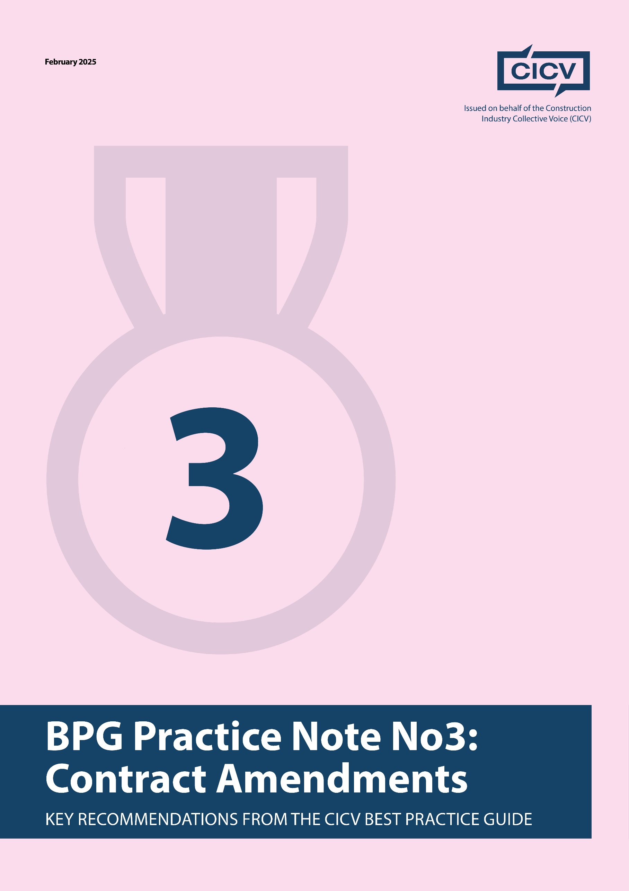

**CICV Best Practice Guide Practice Note 3: Contract Amendments**

**Introduction**

Contract amendments continue to be a major issue in the construction industry, often shifting risk disproportionately onto contractors and subcontractors. This Practice Note aims to highlight **key contractual risks**, explain why **early contract review is essential**, and provide **guidance on managing amendments effectively**.

For those new to the **CICV Best Practice Guide (BPG)**, we strongly recommend reviewing its **contractual and commercial management recommendations** to reduce disputes and improve cash flow stability.

**1. Why Early Contract Review Matters**

Many contractors fail to review contracts until it is too late. A common scenario is when a contractor **only seeks a contract review the day before work starts**—by then, **it’s too late** to renegotiate.

**Review the contract at the tender stage** to identify risks early.  
**If amendments are unreasonable, negotiate or price the risk accordingly.**  
**If the contract terms are unacceptable and non-negotiable, be prepared to walk away.**

**Tip:** Some industry bodies, such as the **Finishes and Interiors Sector (FIS)**, offer **Contract Review Services** to help members identify high-risk clauses before signing.

**2. Common Risk Areas in Contract Amendments**

Below are **some of the most problematic contract amendments** contractors should watch for:

**Payment Terms**

* Amendments that **delay payments beyond standard terms**.
* Retention clauses that **extend payment periods or increase retention percentages**.

**Notice Provisions**

* Onerous **"time-bar" clauses** requiring notification of delays **within a very short timeframe** (e.g., 2-7 days).
* **Strict notice requirements** for submitting claims—refer to **Practice Note 1 (PN1) on Notices** for details.

**Liquidated & Ascertained Damages (LADs)**

* LAD amounts that are **disproportionate to the subcontract value**.
* **No clear cap on liability**, exposing subcontractors to excessive financial penalties.

**Practical Completion**

* Does the subcontract **have its own completion date**, or is it tied to the main contract completion?
* Are there **unfair dependencies** on other contractors' work?

**Variations & Design Responsibility**

* **Unclear variation procedures**—refer to **Practice Note 4 (PN4) on Variations** for best practices.
* Expansion of **Contractor Design Portions (CDP)**, shifting design liability to subcontractors.
* **No clarity on interface issues** with other trades or contractors.

**Site Conditions & Title Issues**

* Clauses that **pass responsibility for ground conditions or existing buildings** to the contractor.
* **Unclear responsibilities** for resolving title issues or dealing with external utility providers.

**Insurance Requirements**

* Contractual insurance provisions that **do not align with your actual policies**.  
  **Design liability clauses** that may not be covered under your Professional Indemnity (PI) insurance.

**3. How to Manage Unfavourable Amendments**

If you encounter **onerous contract amendments**, you have **three options**:

1️ **Negotiate the terms** with the client/contractor. Many amendments can be modified if raised early.

2️ **Price the risk**—factor potential liabilities into your tender pricing.

3️ **Reject the contract and walk away** if the risks are too high.

**Tip:** Industry bodies and trade organisations can provide support if you face unreasonable contract terms.

**4. Industry Response & Conflict Avoidance**

The construction industry is increasingly **concerned about excessive contract amendments**. The **Conflict Avoidance Coalition** is actively working with industry experts to address unfair practices.

If you are seeing **highly unfair or unworkable contract amendments**, reach out to **your trade body** or the **Conflict Avoidance Coalition** for support.

For further insights, watch the **Cash Flow and Contract Webinar** on the **CICV website**.

**Final Advice**

**Always review contracts before signing**—never wait until work is about to start.  
**Understand your obligations and risks**—identify clauses that could impact your cash flow.

**Engage in early discussions**—negotiate terms that protect your interests.  
**Seek expert advice**—use industry contract review services if needed.

Taking a **proactive approach** to contract amendments will help **mitigate risk, reduce disputes, and improve financial stability**.

**Joint Authors:**

**Len Bunton** – [len@buntonconsulting.co.uk](mailto:len@buntonconsulting.co.uk)

**Sean Bradley** – [sean@seanbradleyconsultancy.co.uk](mailto:sean@seanbradleyconsultancy.co.uk)

**Mark Holden-Smith** – [mark@holden-smith.com](mailto:mark@holden-smith.com)

