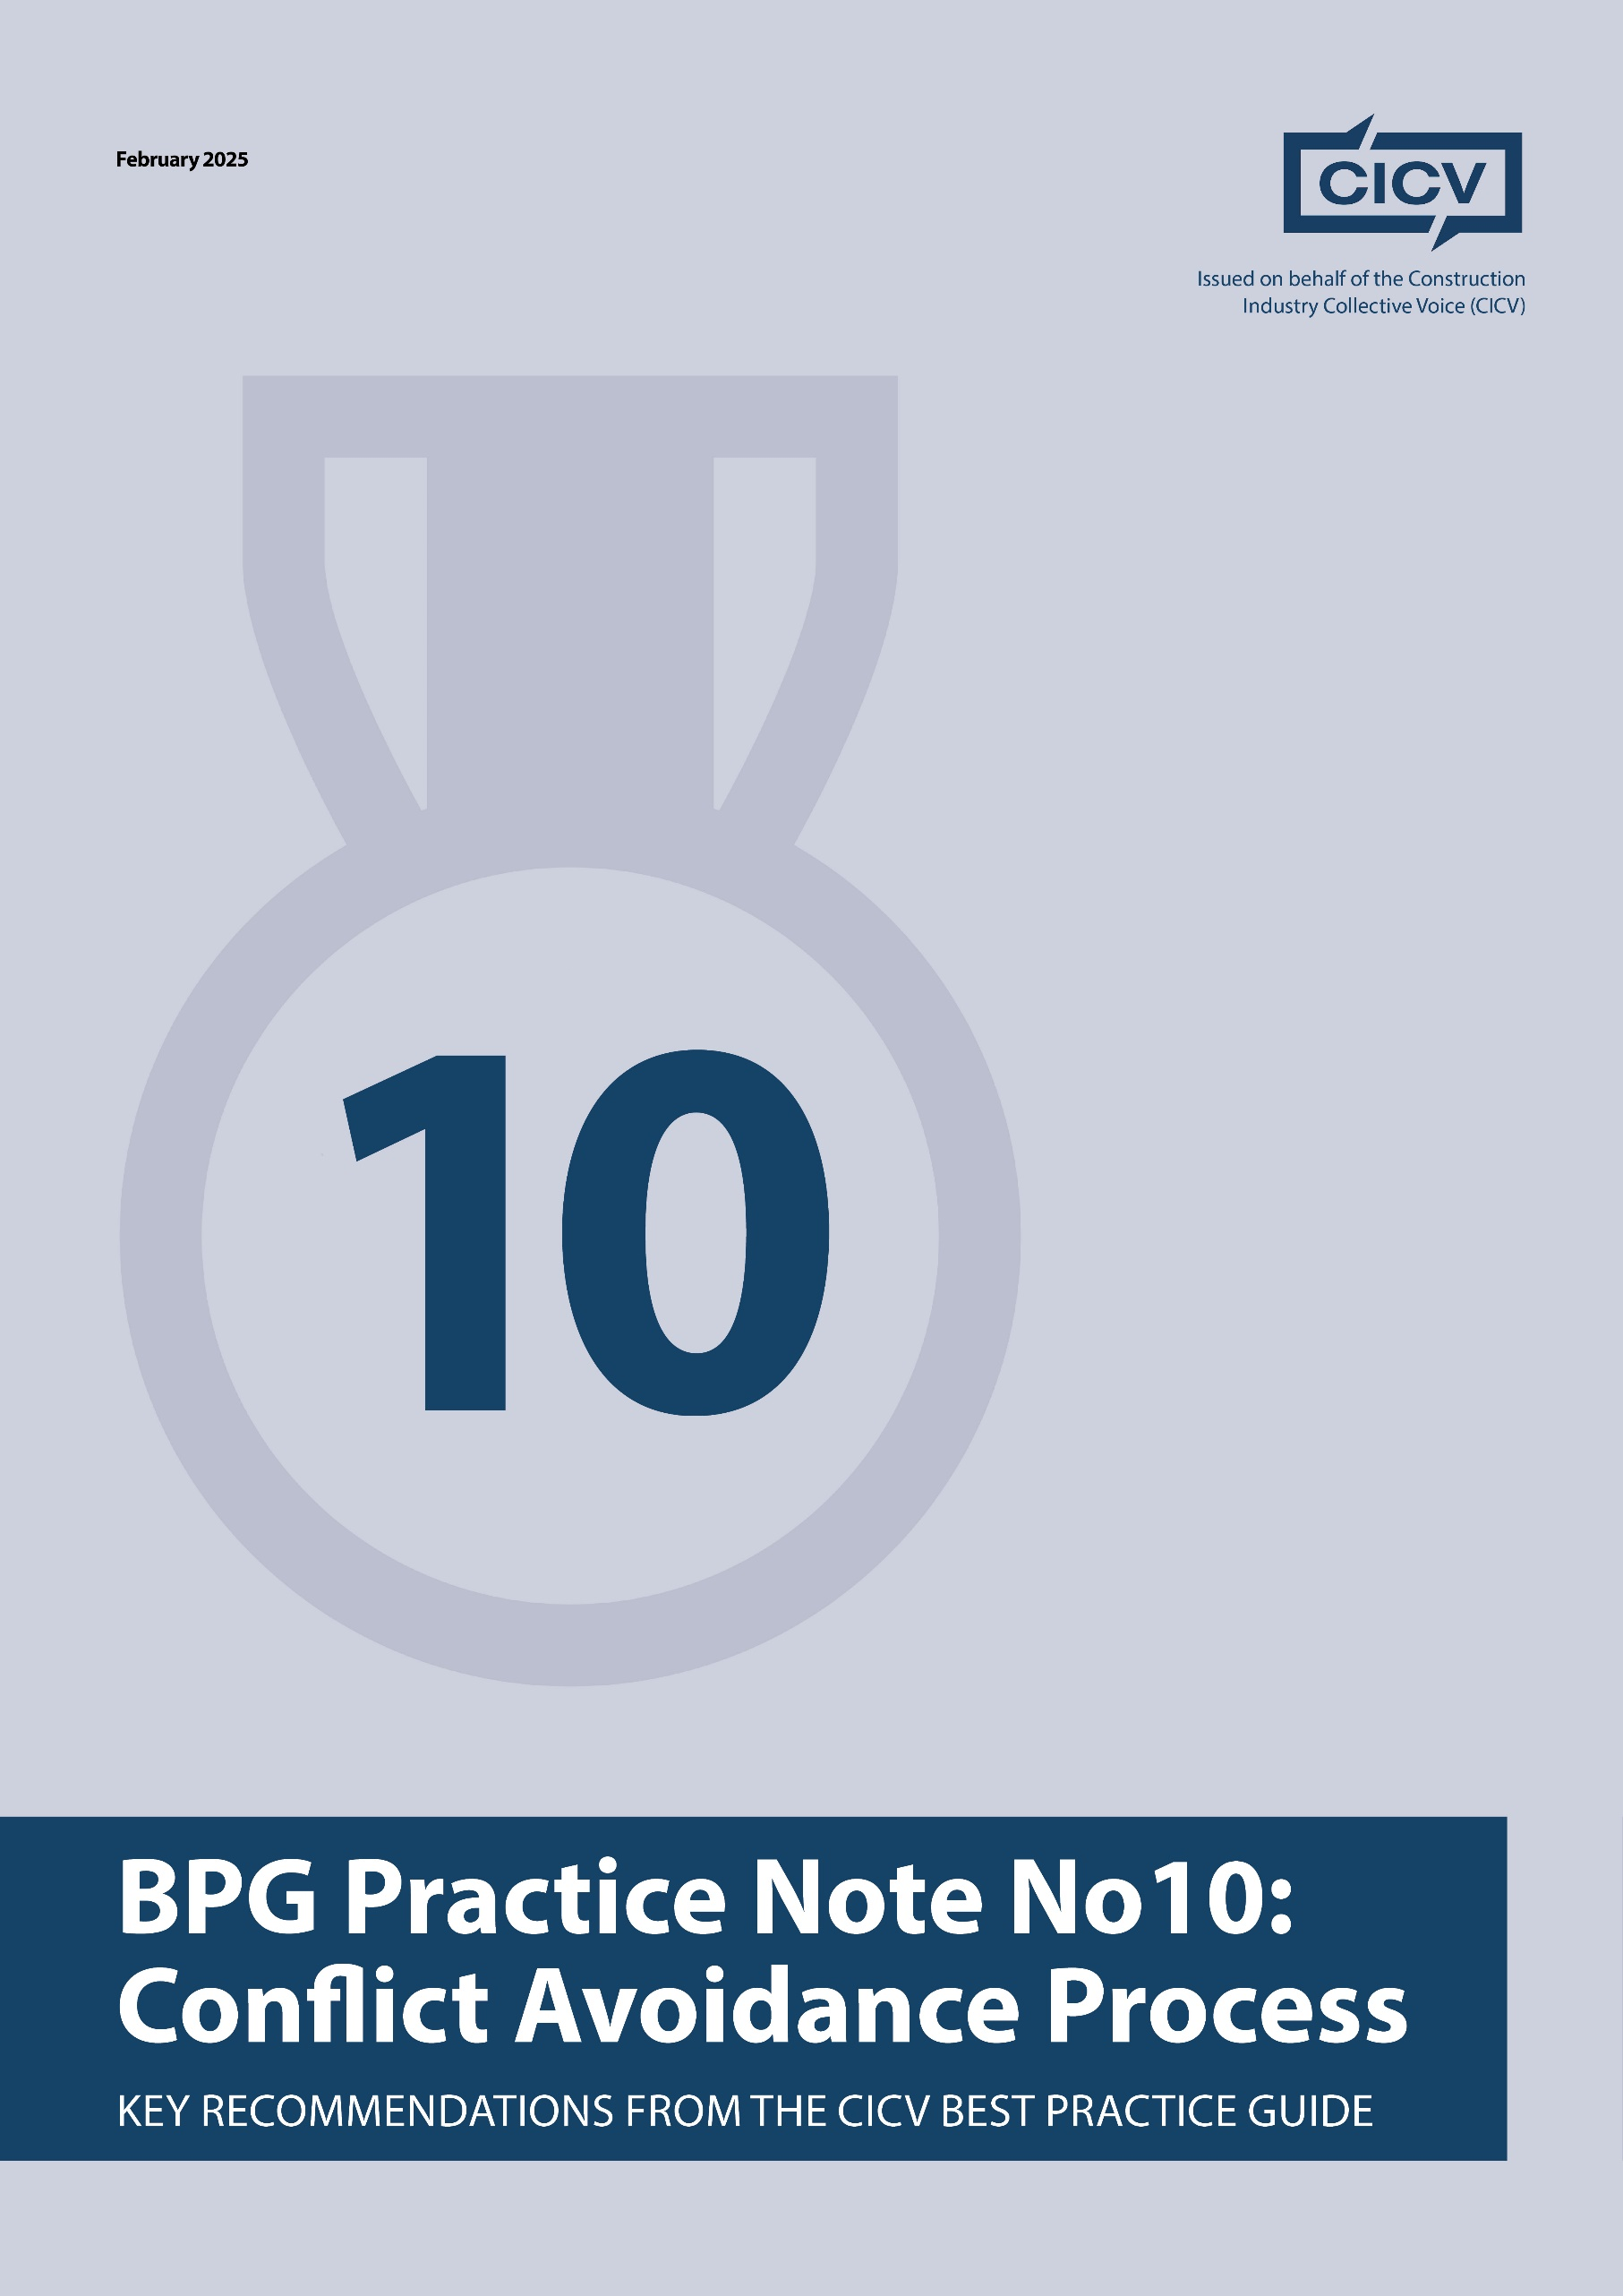

**CICV Best Practice Guide – Practice Note 10: The Conflict Avoidance Process (CAP)**

**Introduction**

This Practice Note deals with the **Conflict Avoidance Process** which is an early intervention process into issues arising on a construction project to resolve these by discussion and to avoid time-consuming and costly disputes.

If you are tendering for a Contract that is based on Bespoke Conditions of Contract, then you **should carefully review** the dispute resolution provisions, as there may be particular requirements that are different from those set out in the Standard Forms

**1. Understanding**

It is very important, the parties involved in a construction project do all they can to avoid disputes and in particular those which may have an impact on payment and cash flow. The first thing you need to do is to sign the **Conflict Avoidance Pledge** and the link to this is [www.capledge.org](http://www.capledge.org). You should encourage your own supply chain and any clients also to sign the **Pledge** so that there is collaboration between the parties to mitigate the prospect of any disputes. You want to be sending out a strong message to your clients that you are a good business to work with, that you want to avoid any contentious issues and concentrate on the delivery of the project.

**2. How does it work**

In committing to the **Pledge** before the contract starts, you are agreeing to use the **Process** to avoid any contentious issues developing. There is a sample clause that can be incorporated into the Contract and this simply says that in the event of any contentious issues arising then the parties will agree to use the **Conflict Avoidance Process** without interfering with the right to refer any dispute to adjudication.

If issues arise then the parties can try to resolve these themselves and if they are unable to do so then they can seek the appointment of a **CAP Professional** who will assist them to understand what the issues are, what each sides position is, and what solution both sides will seek to achieve so that the **CAP Professional** can provide a series of non-binding recommendations for the parties to consider.

The process to date has been operated on a number of different contracts and has proven to be a great success so far. There are no set procedures, and the maximum of flexibility is necessary to try to work out a resolution to the dispute.

**Final Advice**

* **Be proactive** in managing potential issues.
* **Encourage dialogue** rather than confrontational communications and listen to the other side’s position and recognise if they have a legitimate response to the matter.
* Work with the **CAP Professional** to try to find a resolution.
* **Learn** from your experiences.

By implementing these best practices, contractors and subcontractors can ensure clarity, fair compensation, and effective commercial management while minimising disputes.

For further information refer to the **CICV Best Practice Guide, and CAPledge@rics.org**

**Joint Authors:**

**Len Bunton** – len@buntonconsulting.co.uk  
**Sean Bradley** – sean@seanbradleyconsultancy.co.uk  
**Mark Holden-Smith** – [mark@holden-smith.com](mailto:mark@holden-smith.com)

