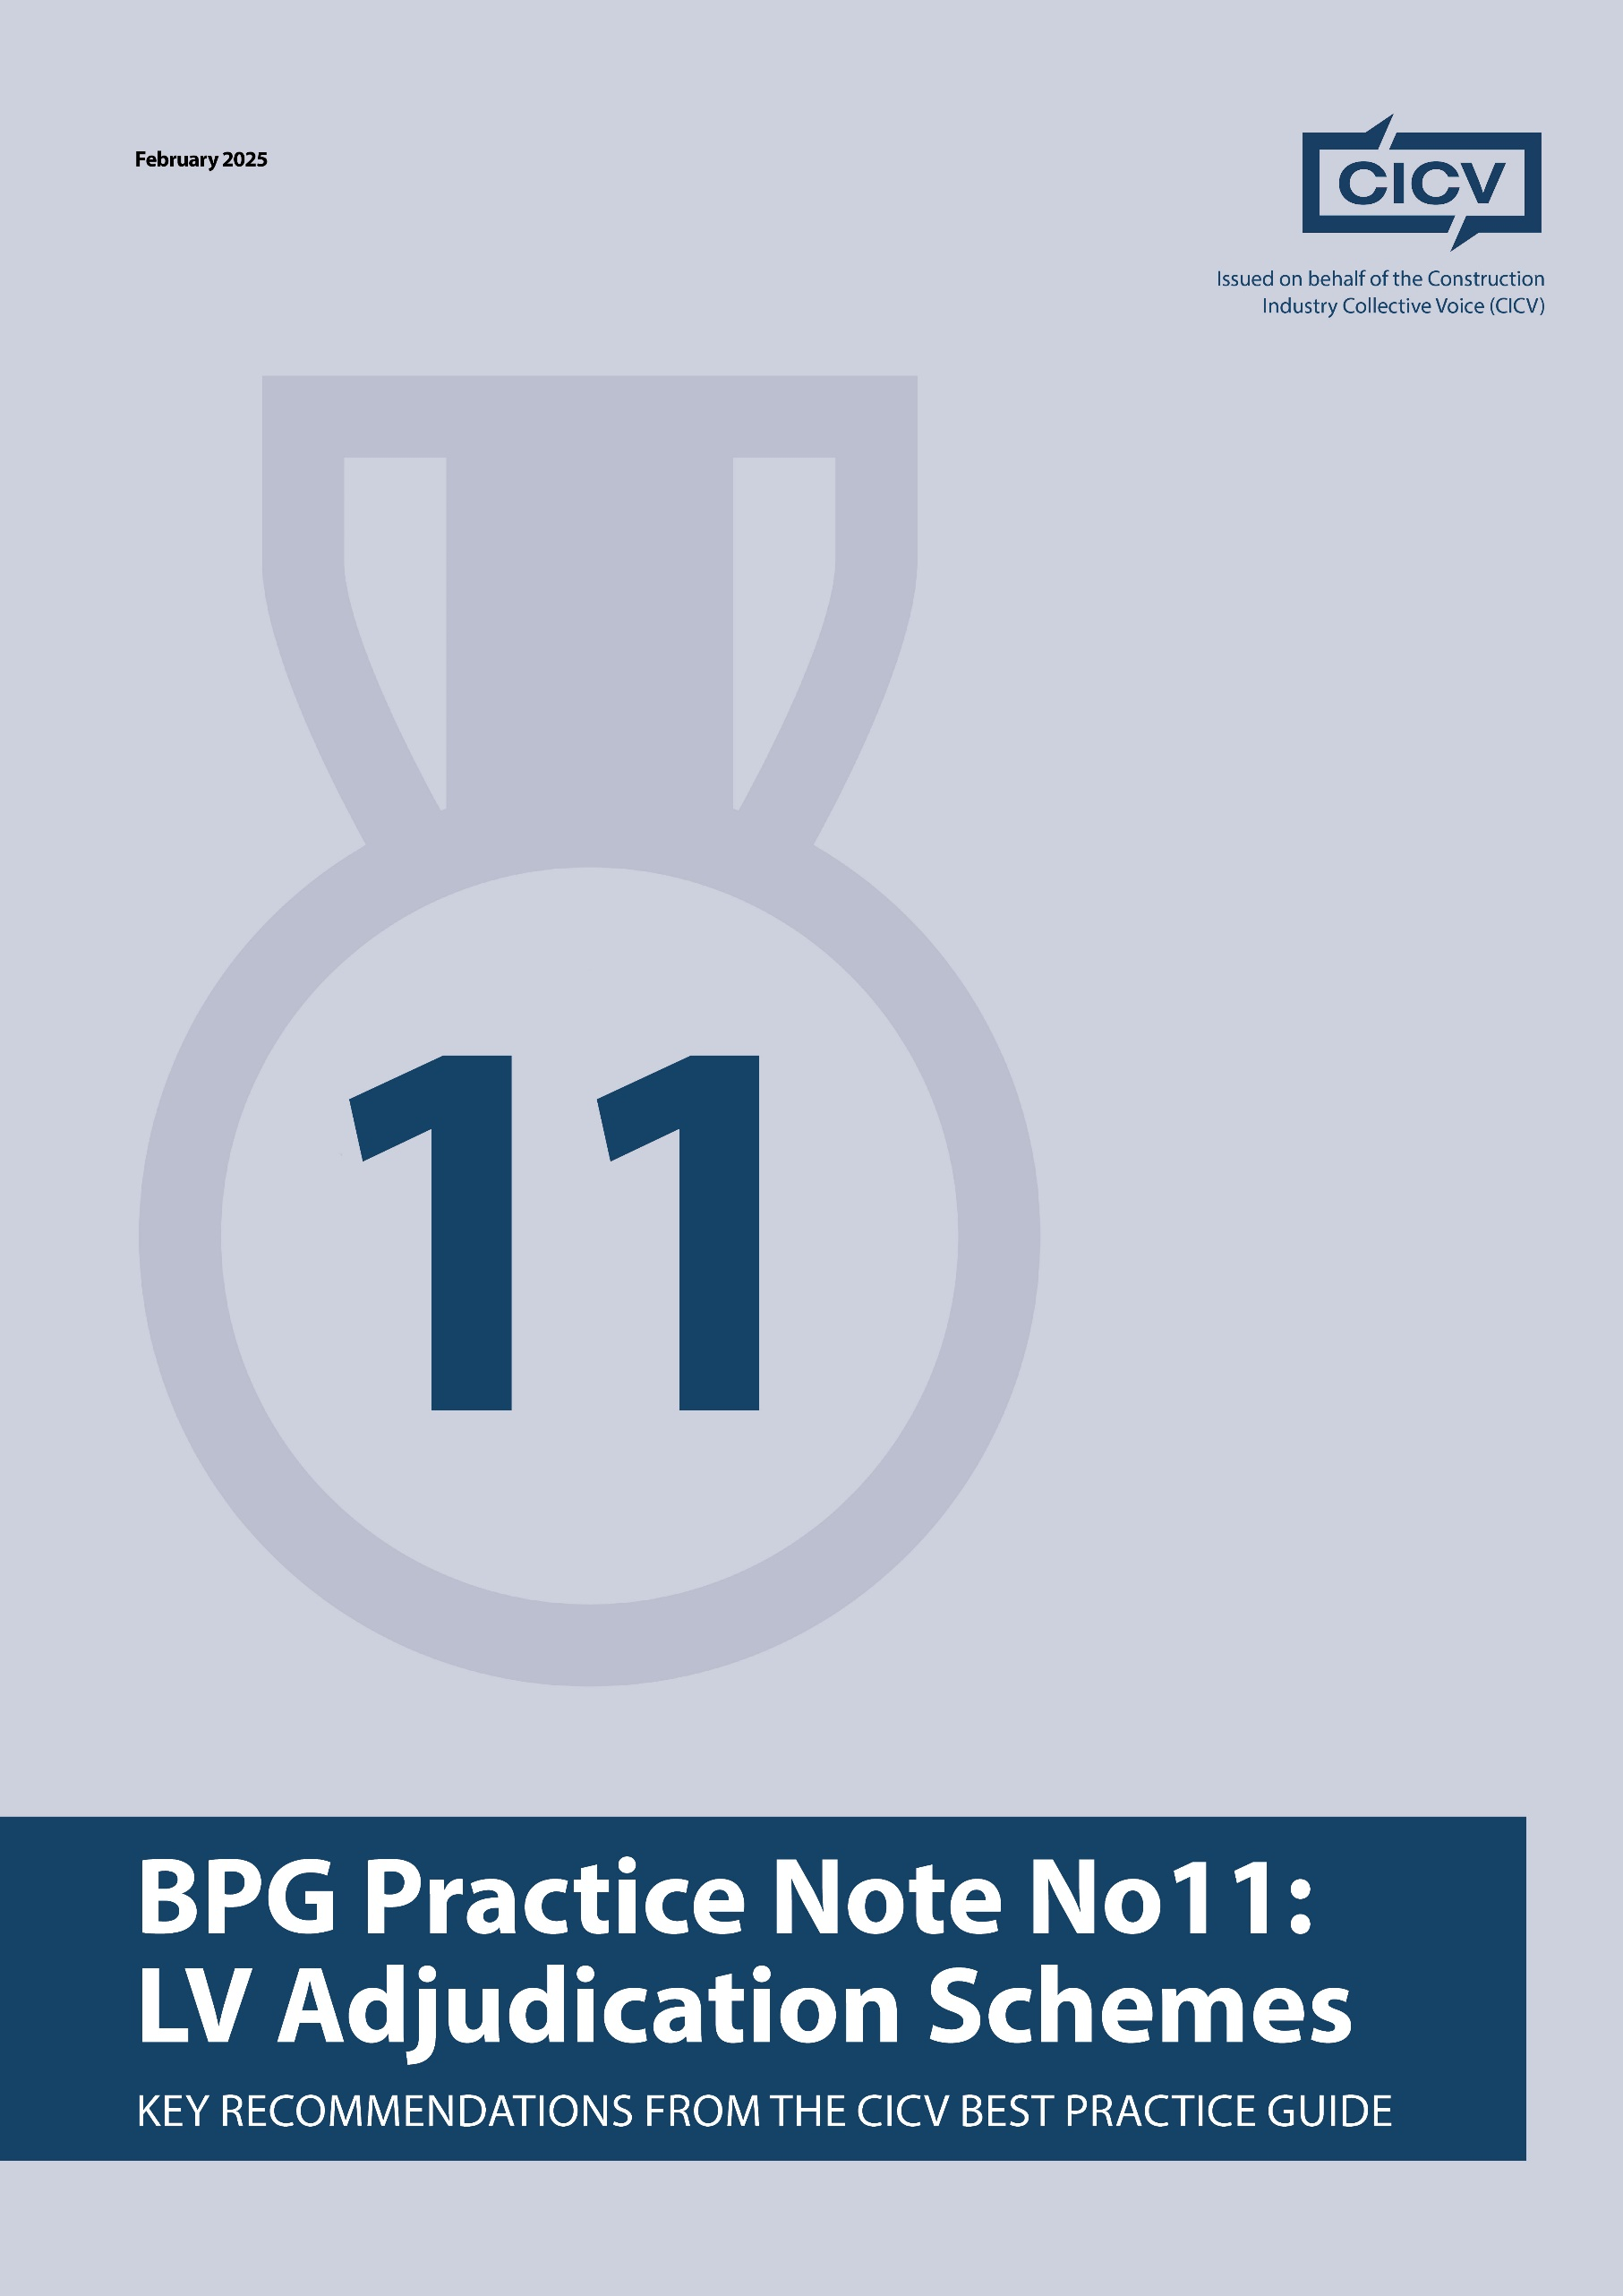

**CICV Best Practice Guide – Practice Note 11: Low Value Adjudication Schemes**

**Introduction**

This Practice Note deals with the **LVD Adjudication Schemes,** which have a fixed level of fee in relation to the value of the dispute and the benefit of this is that it gives a Party some cost certainty if they are unable to resolve matters amicably, and have to refer a dispute to adjudication.

If you are tendering for a Contract that is based on Bespoke Conditions of Contract, then you **should carefully review** the dispute resolution provisions, as there may be particular requirements that are different from those set out in the Standard Forms

**1. Understanding**

Before referring any matter to Adjudication, you will need to build up your case and it is important that you have followed the recommendations given in Practice Note 2 in connection with the compilation of Records. There is a saying which is very relevant to this and that is **“if you fail to prepare then prepare to fail**”. In our experience, most references to Adjudication are not successful where records are absent, and not enough time has gone into the preparation of the case.

**2. How does it work**

Undernoted are the links to the **Low Value Adjudication process** and also the **Summary Adjudication** and you will also find on these links the necessary application forms for the appointment of an Adjudicator.

[Low value adjudication | Dispute resolution | RICS](https://www.rics.org/dispute-resolution-service/drs-services/adjudication-services/low-value-adjudication)

[Summary Adjudication for Construction Claims | RICS](https://www.rics.org/dispute-resolution-service/drs-services/adjudication-services/summary-adjudication)

[ICE Dispute Resolution Services | Institution of Civil Engineers](https://disputeresolution.ice.org.uk/guidance-and-procedures/)

**Final Advice**

* Try to resolve the matter by using the **Conflict Avoidance Process** and refer to **Practice Note 10** .
* Take some external advice if you are **unsure of the process** .
* Refer to our **Practice Note 2 in** relation to the importance of records.
* You may find that once you initiate Adjudication Proceedings that the other party will be **willing to discuss a settlement.**
* **Learn** from your experiences.

By implementing these best practices, contractors and subcontractors can ensure clarity, fair compensation, and effective commercial management while minimising disputes.

For further information refer to the **CICV Best Practice Guide, and CAPledge@rics.org**

**Joint Authors:**

**Len Bunton** – len@buntonconsulting.co.uk  
**Sean Bradley** – sean@seanbradleyconsultancy.co.uk  
**Mark Holden-Smith** – [mark@holden-smith.com](mailto:mark@holden-smith.com)

