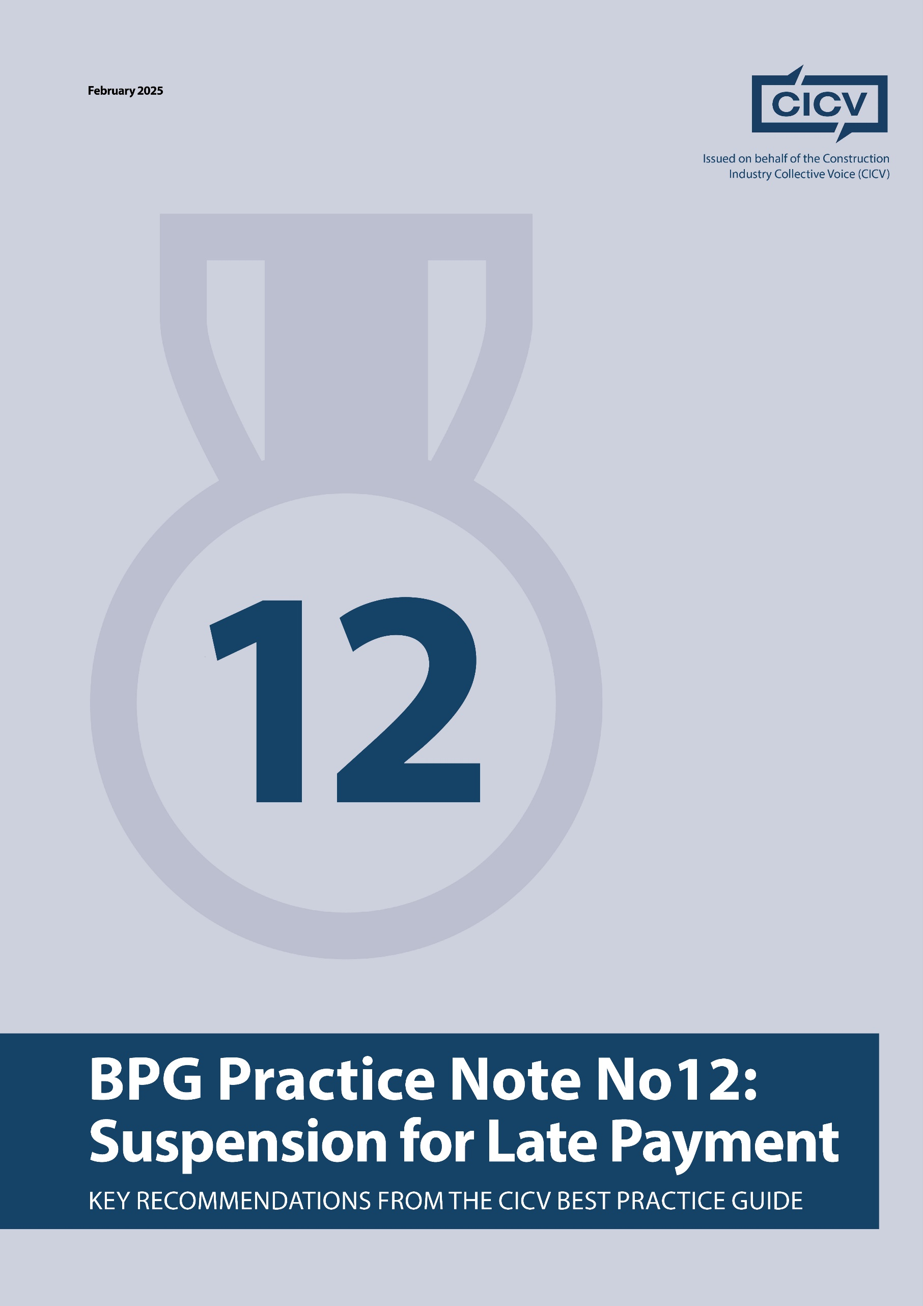

**CICV Best Practice Guide – Practice Note 12: Suspension**

**Introduction**

A right to suspend works can be crucial to reducing the financial effects of late payment, but it is important to understand the different types of suspension, if, when, and how the right may be exercised, how to deal with the effects of suspension in time and money, and what the consequences of suspension are. Drafted by experienced consultants Len Bunton, Sean Bradley, and Mark Holden-Smith, this practice note looks at the statutory and contractual rights to suspend for late payment, and provides guidance on key considerations to maintain best commercial practices.

**1. The Right to Suspend**

There is no common law right to suspend works, so the right to suspend comes from either Section 112 of the Construction Act[1] or from an express term of the contract.

**2. Statutory Right to Suspend**

Section 112 of the Construction Act provides that:

* “any or all” obligations may be suspended.
* Seven days notice is required before obligations can be suspended.
* The party who suspended is entitled to reasonable costs and expenses caused by the exercise of the right to suspend.
* The period of suspension is disregarded in the contract period, including any extra time required in consequence of the exercise of the suspension (i.e. removing resources from the site and re-mobilisation/procurement).
* The right to suspend ends when payment is made in full.

**3. Contractual Right to Suspend**

Generally, contractual rights to suspend follow the statutory provisions above. If your contract does not follow the statutory provisions, then the contractual provisions may or may not be valid, and you should seek the appropriate professional advice.

The JCT Standard Building Contract provides at Clause 4.13 that:

* The Contractor may suspend for a failure to by the Employer to pay in accordance with clause 4.11 subject to 7 days’ notice being given. Be careful here as we have recently seen contacts which amend the 7 days to 14 days.
* Any or all obligations may be suspended until payment is made in full.
* Recovery of the reasonable costs and expenses incurred as a result of the exercise of the right to suspend.
* Extension of time for suspension for late payment, Clause 2.29. 6, refers.
* The right to suspend ends when payment is made in full.

**Key Consideration:** Notwithstanding the statutory right to additional time, the JCT contract provides for an extension of time pursuant to the suspension being a Relevant Event. This means the contractual notice provisions should be followed to provide the contractual right to an extension of time.

The NEC3/4 Engineering and Construction Contract provides that:

* No express provision to suspend for a failure to make payment, meaning the right to suspend comes from the statutory provision outlined above.
* If Option Y(UK)2 is applicable then the suspension is a compensation event, which provides compensation in time and money for the suspension.

**Key Consideration**: Notwithstanding the statutory rights, the NEC contractual provisions for compensation events require the Contractor to follow the notice provisions, and a failure to do so will result in the Contractor becoming time-barred from claiming the compensation.

**4. Wrongful Suspension**

A wrongful suspension is when the suspension is not exercised in accordance with the applicable statutory or contractual right. This may mean, for example, that the required notice period was not given or that the payment was not late, or that your application for payment was not issued strictly in accordance with the contract.

**Key Considerations:**

* Make sure you follow the notice provisions carefully. Please refer to PN’s 1 and 1A for the recommendations on Notices.
* A wrongful suspension is serious and may even be a repudiatory breach of the contract, so ensure the appropriate professional advice is sought on the matter.
* The 7-day notice means **7 full days**. For example, if the notice is given on a Monday, it would be wise not to actually suspend until the following Tuesday, in order to prevent a claim that the complete notice period was not given.

A disagreement about the payment amount due is not a late payment. A late payment means late payment of the notified sum. A disagreement over the amount of the notified sum is a separate matter.

If you are unsure about any element of the matter of suspension, always seek professional advice before you suspend.

**Final Advice**

* There are differences in the contractual and statutory provisions that require attention to ensure the correct procedure is being followed and to avoid the suspension being invalid, or to avoid a lack of entitlement to additional time and/or payment for the suspension.
* A wrongful suspension can have extremely severe consequences so strict compliance with the notice provisions is critical.
* Always seek professional assistance when considering suspension to avoid compromising your contractual position.

For further information, refer to the **CICV Best Practice Guide.**

**Joint Authors:**

**Len Bunton** – len@buntonconsulting.co.uk  
**Sean Bradley** – sean@seanbradleyconsultancy.co.uk  
**Mark Holden-Smith** – [mark@holden-smith.com](mailto:mark@holden-smith.com)

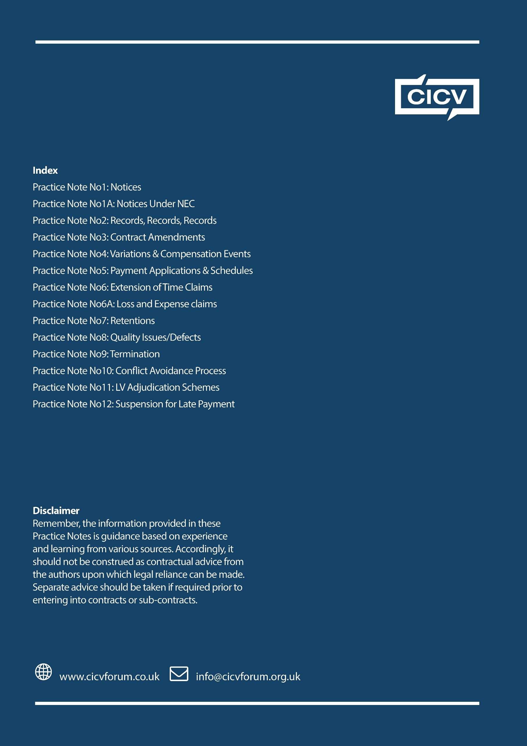

1. The Housing Grants, Construction and Regeneration Act 1996, as amended by the Local Democracy, Economic Development and Construction Act 2009.