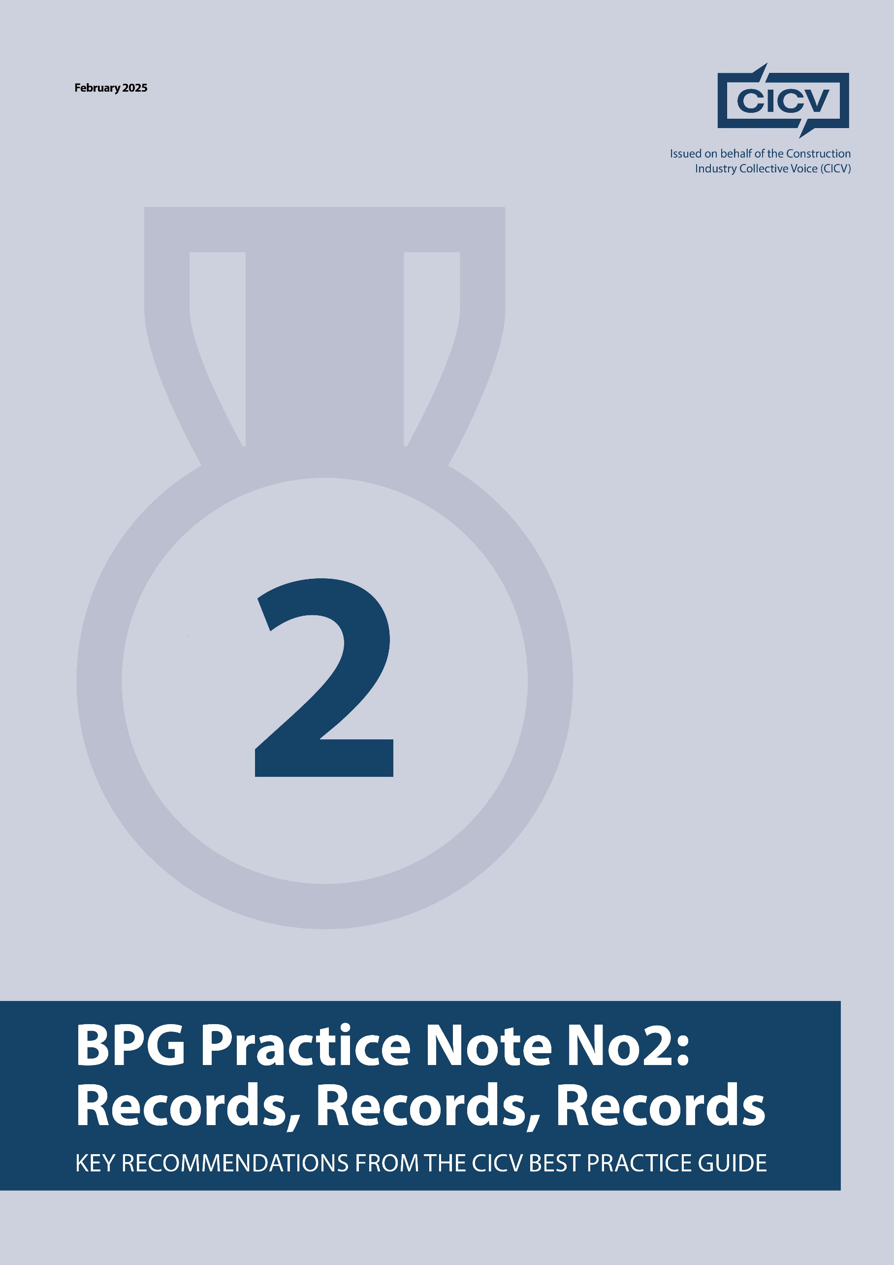

**CICV Best Practice Guide - Practice Note 2: Records, Records, Records**

This Practice Note is the second in a series designed to enhance commercial management in construction projects by promoting best practices for record-keeping. Authored by experienced consultants Len Bunton, Sean Bradley, and Mark Holden-Smith, it outlines key recommendations from the CICV Best Practice Guide (BPG) to help subcontractors and contractors safeguard their contractual position.

**The Importance of Record-Keeping in Construction Contracts**

One of the most common mistakes contractors make is failing to maintain comprehensive records of contract events. These records become crucial if a contractual claim arises or if an employer seeks to impose liquidated damages.

As highlighted in [Practice Note 1](https://www.linkedin.com/feed/update/urn:li:activity:7296167065638371328/), ensuring that contractual notices are issued in compliance with the agreement is fundamental. This is particularly important when pursuing claims for **extensions of time** or **loss and expense**, as failure to provide proper notice may invalidate a claim.

A recurring issue in construction disputes is the loss of project knowledge when key personnel—such as site managers, contracts managers, or commercial managers—leave their roles. Additionally, poor management of electronic files, including missing or deleted documents, can create significant challenges. To mitigate these risks, all project records should be **securely stored and readily accessible** from the outset of the contract.

**Key Records to Maintain**

To ensure robust documentation, contractors should retain the following records:

**1. Essential Contract Documentation**

* All tender documents.
* Emails and electronic communications (both inbox and outbox).
* Hard copies of key correspondence (recommended for larger projects).

**2. Meeting and Site Documentation**

* Pre-start meeting minutes.
* Progress meeting minutes.
* Meeting records with subcontractors.

**3. Project Execution Records**

* Site diaries documenting daily progress.
* Site instructions.
* Requests for Information (RFIs) with a tracker showing request dates and response times.
* Records of variations to the contract.
* Construction drawings and a maintained drawing register.

**4. Programme Management**

* Tender programme.
* Contract programme and any progress updates.
* As-built programme (critical for extension of time claims).
* Additional programming documentation.

**5. Defects and Quality Control**

* Snagging lists.
* Defect resolution records, including dates of client acceptance.

**6. Visual Evidence**

* Weekly photographs with date stamps and annotations.
* Video recordings of progress and site conditions (helmet-mounted camera systems can be used to document delays, disruptions, and inaccessible areas).

**7. Subcontractor Documentation**

* Ensure that all subcontractors also maintain detailed records, as their support may be needed for claims.

**Consequences of Poor Record-Keeping**

Failure to maintain adequate records can **severely undermine** a contractor’s ability to:

* **Pursue contractual claims** (e.g., extension of time, loss and expense).
* **Defend against employer allegations** (e.g., delays, defective work).
* **Support adjudication or legal proceedings**, as weak documentation reduces the likelihood of success.

Without clear and comprehensive records, a contractor pursuing an adjudication may face:

* **Unsuccessful claims due to lack of evidence.**
* **Liability for adjudicator and consultant fees.**
* **Serious financial repercussions for the business.**

**Final Advice**

***“If you fail to prepare, then prepare to fail.”***

Proper record-keeping is not just an administrative task—it is a **critical business safeguard**. By following these best practices, contractors can improve project management, **avoid disputes**, and **ensure contractual compliance**.

**Joint Authors**

**Len Bunton** – len@buntonconsulting.co.uk  
**Sean Bradley** – sean@seanbradleyconsultancy.co.uk  
**Mark Holden-Smith** – [mark@holden-smith.com](mailto:mark@holden-smith.com)

