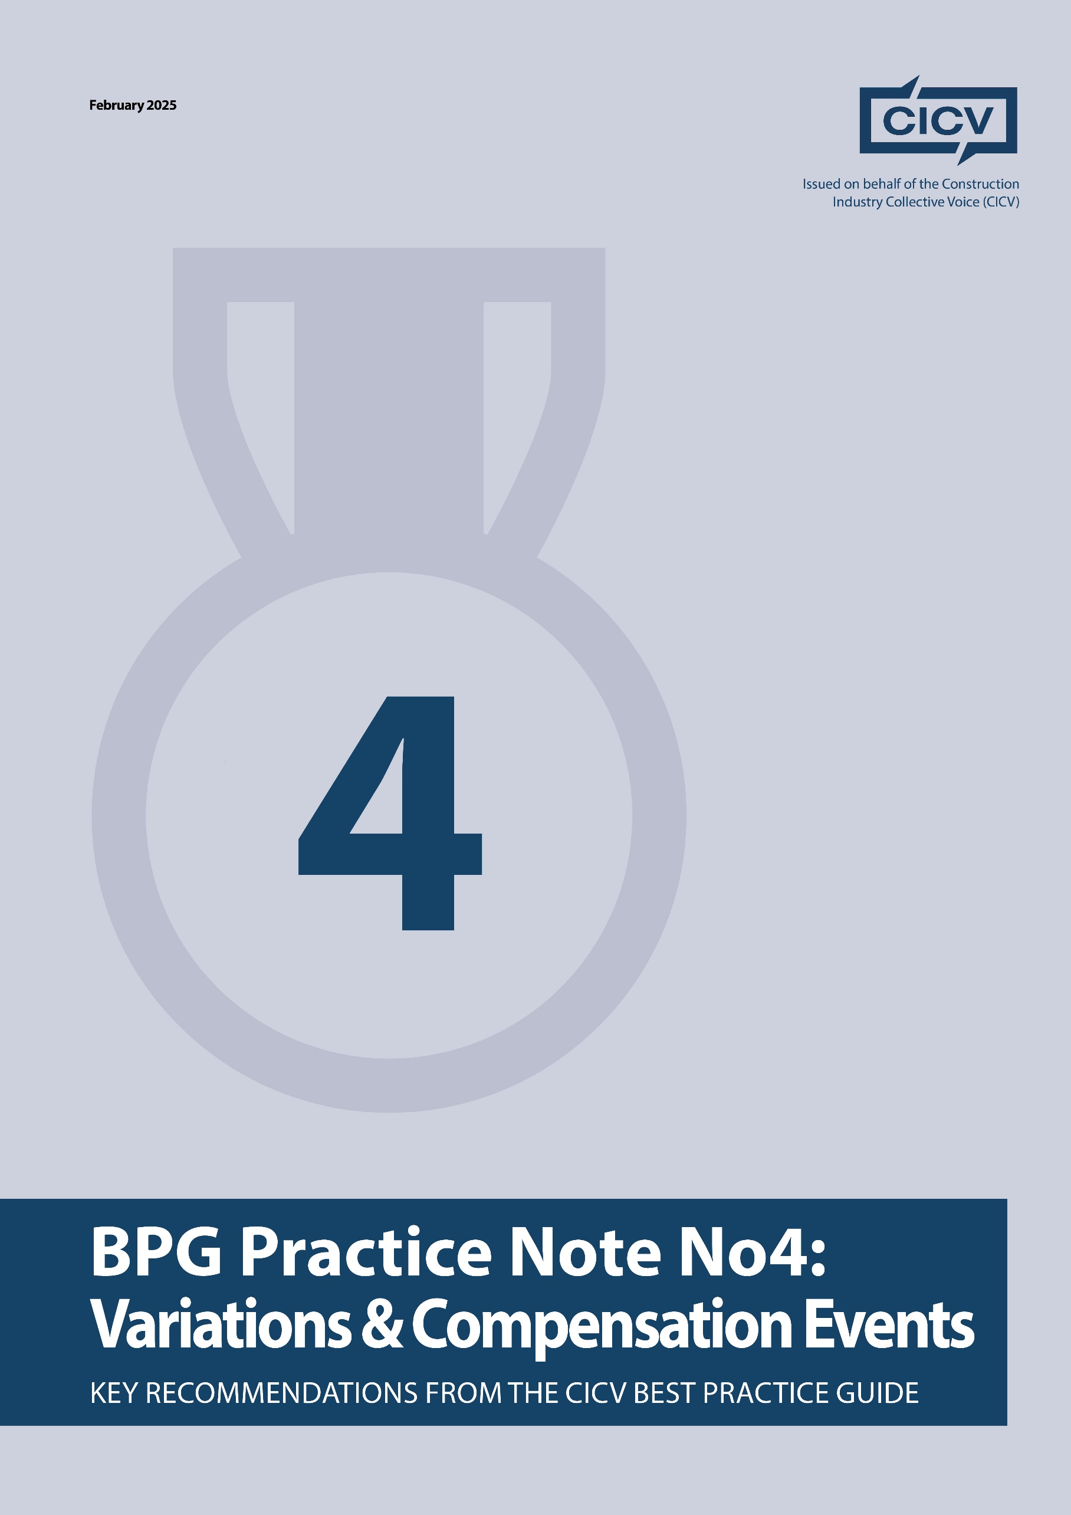

**CICV Best Practice Guide – Practice Note 4: Variations & Compensation Events**

**Introduction**

This Practice Note highlights the risks associated with variations in construction contracts, including **onerous clauses, conditional precedents, and the risks of performing work without formal instructions**. It builds upon **Practice Note 1 on Notices** and reinforces the importance of the **"no instruction, no work"** principle.

A key challenge for both **contractors and subcontractors** is completing work on-site only to face disputes over payment. This PN outlines how to **identify and mitigate contractual risks related to variations**, ensuring proper documentation and adherence to contract terms.

**1. Understanding Variations and Instructions**

One of the most common clauses in subcontracts requires that **all variations must be formally confirmed in writing**. In many cases, failure to obtain a **written variation order** may result in the subcontractor having **no entitlement to additional time or money**.

**How Variations Typically Arise:**

* Site managers often issue **verbal instructions** on-site for additional work.
* Subcontractors, keen to progress the project, proceed without formal written approval.
* When the final account is settled, contractors dispute or reject the variation due to a lack of records or proper authorisation.

**2. Best Practices for Managing Variations**

**Step 1: Always Obtain Written Instructions**

If a verbal instruction is given on-site:

* **Request a formal site instruction (SI) in writing** from the site manager.  
  **Email the Contractor’s Quantity Surveyor (QS)**, seeking confirmation that it is a variation.
* **Provide a cost estimate and request written approval** before proceeding.
* **If no written instruction is received, do not proceed** unless the subcontract allows the subcontractor to issue a variation notice. If the contract **requires written approval**, failing to obtain it may mean the work will not be paid for.

**Step 2: Clarify the Contractor’s Position**

If the **contractor refuses or delays issuing an instruction**, this is a **red flag** and a potential dispute risk. In such cases:

* Explain that the **contract requires written approval** to avoid future disputes.
* If the contractor insists that work must start without a written instruction, **escalate the issue immediately**.
* **Document the request and refusal** for future reference.

**3. Keeping Accurate Records for Variations – refer also to PN 2**

Maintaining proper records **ensures variation claims are substantiated**. The following records should be maintained:

* A **log of all variation requests** with request and response dates.
* A **tracker for site instructions (SIs)** received and whether they were in writing.
* **Photographic and video evidence** of the work before, during, and after completion.
* **Labour, material, and time records** for all additional work.
* Regular **correspondence with the contractor’s QS** to ensure agreement on variation costs.

**Tip:** Agree on variations **as they occur** rather than leaving disputes until the final account stage.

**4. Handling Disputes Over Variations**

If an **instruction is disputed**, or if the contractor refuses to issue a variation order:

* **Red flag the issue** and document the request.
* **Request an official instruction** allowing the work to proceed, pending valuation under the contract.
* **If no resolution is reached**, consider **alternative dispute resolution (ADR)** options, such as the **Conflict Avoidance Process (CAP)**, and the **Low Value Adjudication Schemes.**
* Readers should note however the provisions in the **JCT** and **SBBC Contracts** in **Schedule Part 2**, which relates to **Clause 5.3** in the Contract, which allows for a **Variation Quotation** to be submitted, and this will include the direct loss andexpense to be incurred. This brings cost certainty to the employer, and the contractor, and goes a long way to eliminate payment disputes.

**5. Final Advice**

* **Be proactive in managing variations**—do not wait until the final account stage.
* **Always insist on written instructions**—verbal agreements are not enforceable.
* **Keep detailed records**—this will strengthen any claims for additional payment.
* **Communicate regularly with the contractor’s QS**—avoid last-minute disputes.

By implementing these best practices, contractors and subcontractors can ensure **clarity, fair compensation, and effective commercial management** while minimising disputes.

**Joint Authors:**

**Len Bunton** – len@buntonconsulting.co.uk  
**Sean Bradley** – sean@seanbradleyconsultancy.co.uk  
**Mark Holden-Smith** – [mark@holden-smith.com](mailto:mark@holden-smith.com)

