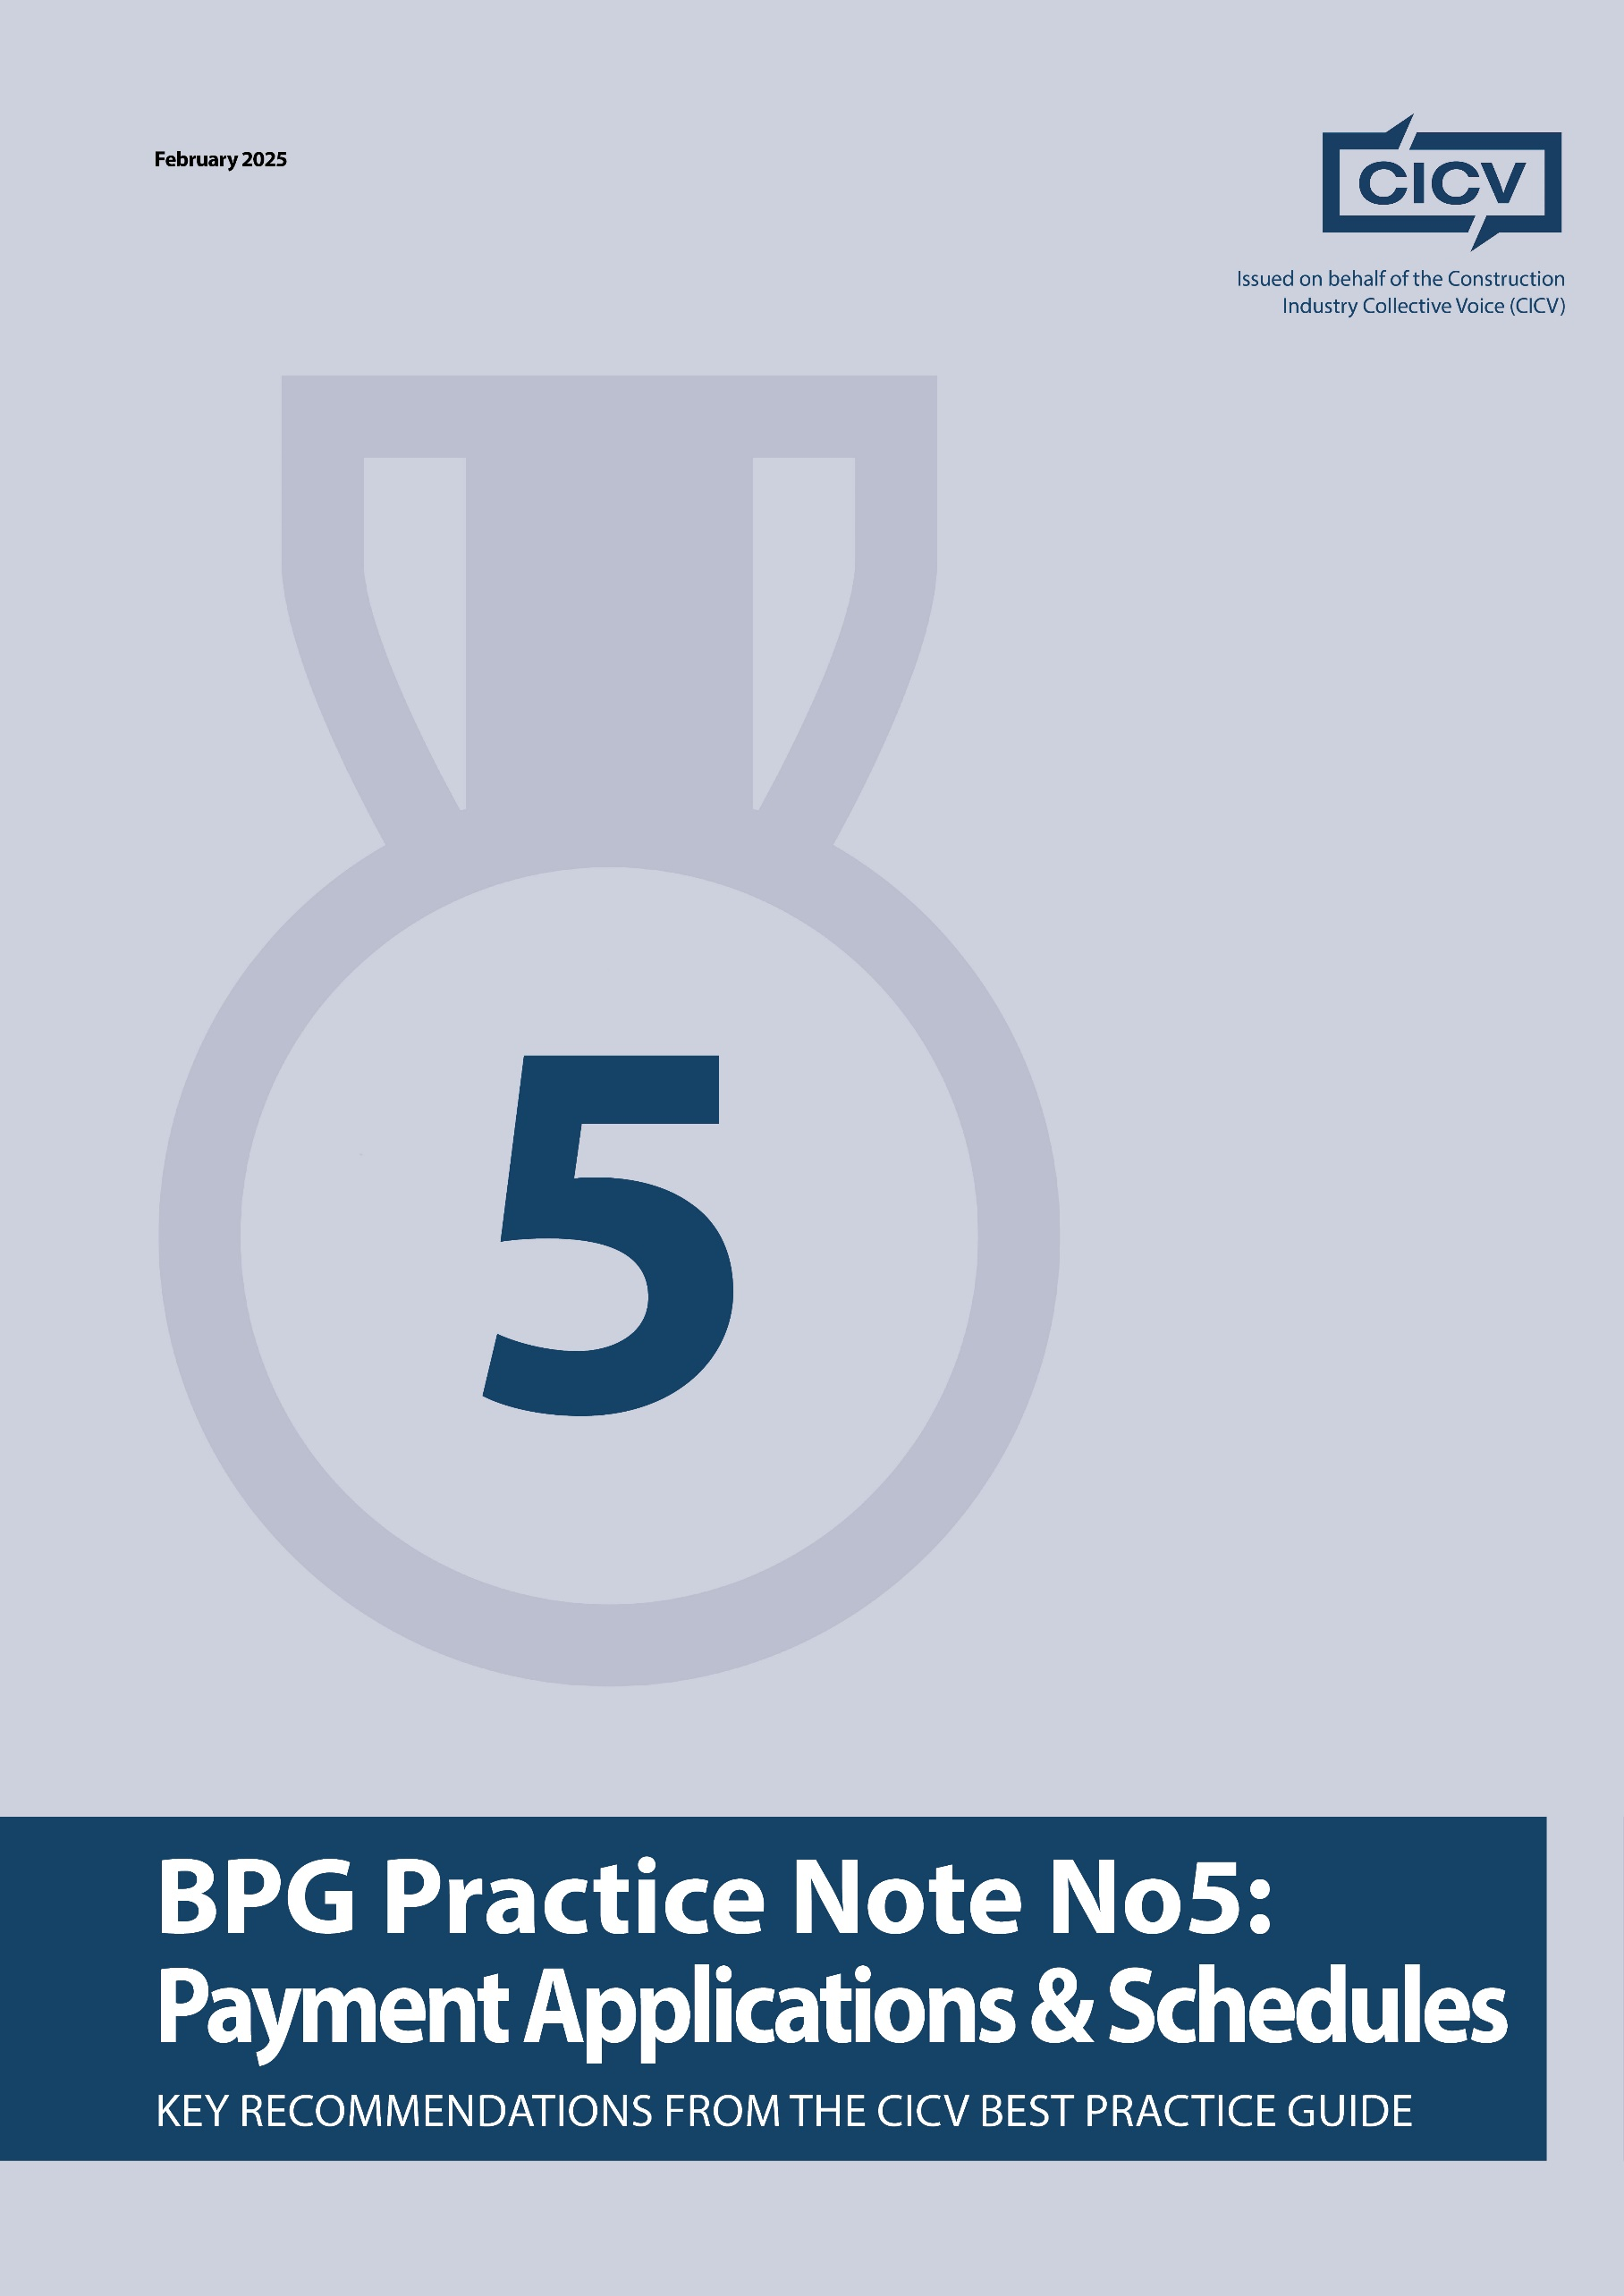

**CICV Best Practice Guide – Practice Note 5: Payment Applications & Schedules**

**Introduction**

Ensuring prompt and full payment is critical to maintaining healthy cash flow in construction projects. This Practice Note provides **best practices for preparing and managing payment applications** to maximize your chances of getting paid on time and in full.

Once entitlement—such as for variations (as covered in **Practice Note 4**)—is established, the next challenge is securing payment. Many businesses fail to take a proactive approach to financial management, leading to cash flow problems and disputes.

This guide outlines key steps to **streamline payment applications**, **minimize delays**, and **protect your financial position**.

**1. Understanding Payment Terms & Cash Flow Impact**

**Before Signing the Contract:**

**Evaluate the impact of payment terms on your cash flow.** If the terms are unfavourable, discuss alternative provisions with the Client.

**Agree on a clear payment schedule** before signing the contract. The schedule should specify:

* Application date
* Due date
* Final date for payment
* Deadlines for issuing payment and pay-less notices

**Ensure the contract provides fair and realistic payment terms.** If provisions do not align with your cash flow needs, negotiate adjustments.

**2. Submitting Payment Applications**

Many disputes arise simply because payment applications are **not submitted correctly or on time**. Follow these steps to ensure compliance:

**Know where to send applications.** Some contracts require applications to be sent to both the **Client’s/Contractor’s QS** and another designated contact. Failure to comply may result in delayed or missed payments.

**Use email tracking.** Enable **delivery and read receipts** when submitting applications. Confirm that electronic submissions are accepted under the contract.

**Follow contract format requirements.** Ensure your application is **detailed, clear, and well-documented**, including:

* Quantities with supporting evidence
* Material and plant invoices
* Site instructions
* Photographic records
* Any other relevant back-up documentation

**Tip:** Many payment applications get rejected due to lack of supporting evidence. Make sure yours is comprehensive and meets the contract’s requirements.

**3. Follow-Up and Communication**

**Call the Client/Contractor QS after submission** to confirm receipt and check if additional information is needed.

**Send a follow-up email** summarizing the discussion to document the status of the application.

**Engage in proactive communication**—don’t just rely on email; pick up the phone and discuss payment matters directly.

Before the contract begins, schedule a **pre-contract administration meeting** to ensure all financial procedures are agreed upon and documented.

**4. Managing Payment Delays & Non-Payment**

**If payment is not received by the final due date**, you may have the right to **suspend work** until payment is made in full.

**However, before suspending work, follow all contractual notice requirements carefully** to avoid breaching the contract.

**Monitor outstanding payments closely**—do not allow unpaid invoices to accumulate.  
**Act quickly** if payments are overdue. Many businesses let unpaid balances drag on, leading to serious financial strain.

**Remember: It’s YOUR money. It should be in YOUR bank.**

**Final Advice**

Understand your contract’s payment provisions before signing.

Submit applications correctly and on time.

Provide full supporting evidence to avoid rejections.

Follow up and communicate proactively.

Enforce your rights if payments are late, but always follow proper procedures.

By adopting these best practices, you can **protect your financial position, improve cash flow, and reduce payment disputes** in construction projects.

**Joint Authors:**

**Len Bunton** – [len@buntonconsulting.co.uk](mailto:len@buntonconsulting.co.uk)   
**Sean Bradley** – [sean@seanbradleyconsultancy.co.uk](mailto:sean@seanbradleyconsultancy.co.uk)   
**Mark Holden-Smith** – [mark@holden-smith.com](mailto:mark@holden-smith.com)

