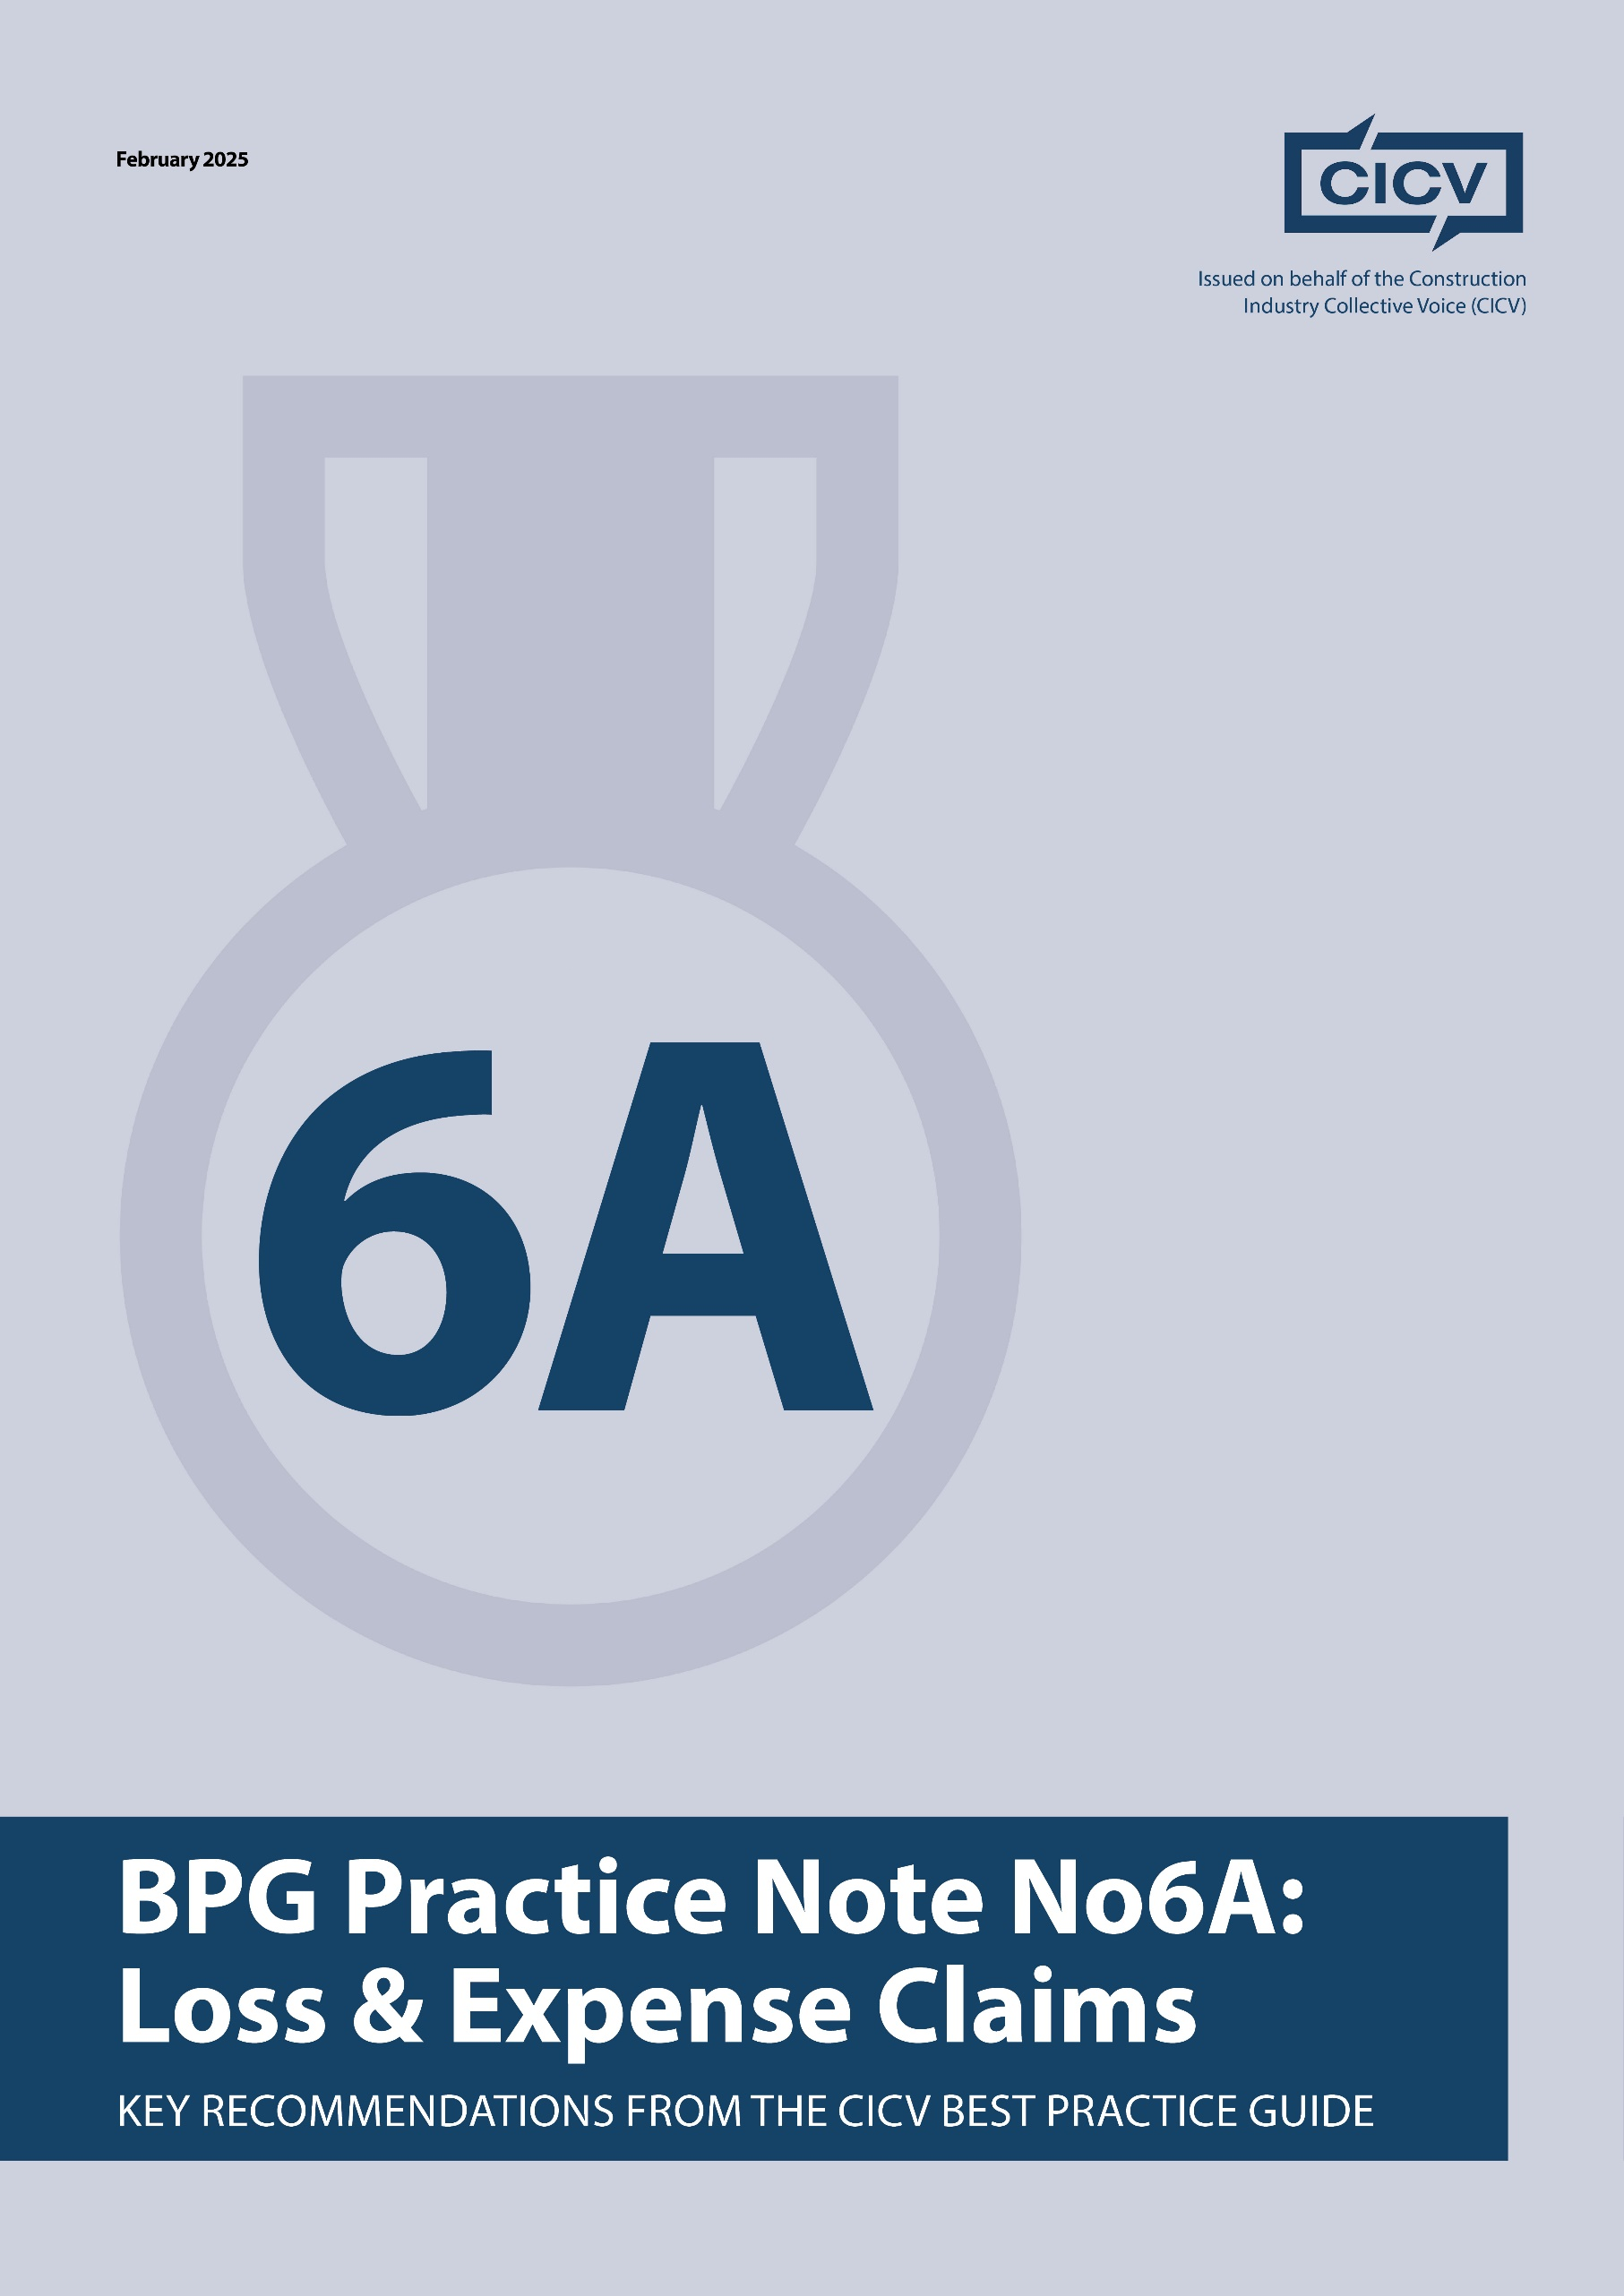

**CICV Best Practice Guide – Practice Note 6A: Loss and Expense Claims**

**Introduction**

This Practice Note deals with the entitlement of contractors to submit a claim for loss and expense claims in accordance with the provisions of the **2024 Standard Building Contract with Quantities.** The purpose of these provisions is to allow the contractor to recover loss and expense, for example in relation to obtaining an extension to the Contract Completion Date.

If you are tendering for a Contract that is based on Bespoke Conditions of Contract, then you **should carefully review** the loss and expense provisions, as there may be particular requirements that are different from those set out in the Standard Forms

**1. Understanding**

It is very important, that you understand the provisions of **Clauses 4.20-4.24 Loss and Expense** and this clause sets out the requirements and what you must do to satisfy these contractual provisions. A critical feature is that you follow the notice provisions, and we refer you to our **Practice Notes 1 and 1 A,** which highlight for you the requirements for the submission of notices. A further point here is that the submission of notices under this clause is what is known as a **condition precedent**, and this has recently been established in the Courts as a fundamental obligation to give a notice before in any entitlement can arise,

.

**2. Submitting**

A notice is required by the Contractor, notify the Architect//Contract Administrator as soon as the likely effect of a **Relevant Matter** on the regular progress of the likely nature and extent of any loss and/or expense arising from deferment of possession becomes [or should have become reasonably apparent to him.

**Relevant Matters** are identified at **Clause 4.22,** so you have to refer to one or a number of these, depending on the issues that have resulted in a delay. Please note that not all **Relevant Events** are **Relevant Matters**.

**Clause 4.21.1-4** deals with notifications and ascertainment**.** We cannot stress again the importance of submitting detailed timeous notices. Your notification must identify the Relevant Matter and must also include the contractor’s initial assessment of the loss and/or expense incurred and any projection of loss and expense in the future and this is then submitted to the Architect/Contract Administrator or the Quantity Surveyor to ascertain the loss and/or expense incurred.

Within 28 days of receipt of the initial assessment the Architect/Contract Administrator or the Quantity Surveyor shall notify the Contractor of their assessment. You would be entitled to include your assessment in your payment applications and will be entitled to receive payment. **Clause 4.23** makes it clear that any amounts ascertained under **Clause 4.21** shall be added to the **Contract Sum**.

**3. Follow-Up**

This is an ongoing process during the currency of the contract, and also you should be responding to any request for further and better information to be submitted to support your claims. You ae entitled to be reimbursed for the actual loss and expense incurred, and the practice of basing your loss and expense on the Contract Preliminaries is to be discouraged, as it will probably be rejected.

**4. Managing**

The submission of notices is critical here and you are referred to **Practice Notes 1 and 1** **A** on **Notices**. Equally important is that you keep accurate records of the causes and impact of delays, and you are again referred to **Practice Note 2** on **Records.**

**Final Advice**

* **Be proactive** in managing the submission of notices.
* **Maintain records** throughout the project.
* **Your loss and expense submissions will be rejected if** you have not fully substantiated your position.
* **Continually update** your submissions.

By implementing these best practices, contractors and subcontractors can ensure clarity, fair compensation, and effective commercial management while minimising disputes.

**Joint Authors:**

**Len Bunton** – len@buntonconsulting.co.uk  
**Sean Bradley** – sean@seanbradleyconsultancy.co.uk  
**Mark Holden-Smith** – [mark@holden-smith.com](mailto:mark@holden-smith.com)

