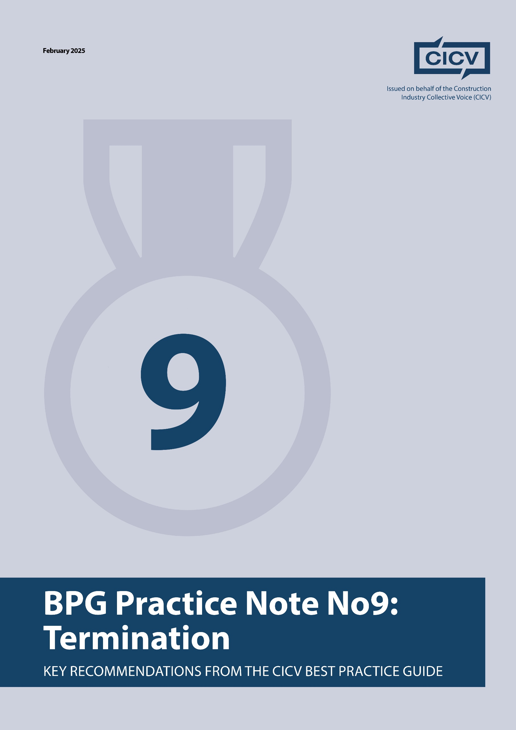

**CICV Best Practice Guide – Practice Note 9: Termination**

**Introduction**

This Practice Note deals with the Termination Provisions in accordance with the provisions of the **JCT/SBCC Standard Building Contract 2024.** It is a complex area which needs to be managed carefully.

If you are tendering for a Contract that is based on Bespoke Conditions of Contract then you **should carefully review** the specific termination provisions, as there may be particular requirements that are different from those set out in the Standard Forms

**1. Understanding**

It is very important, that you understand the provisions of **Section 8 Termination**. There are two sections, the first being up termination by the **Employer** and the second being termination by the **Contractor.**

One very important issue that relates to both of the above concerns Notices under **Section 8**. **PN1** deals with **Notices** generally. **Clause 8.2** deals with notices. Notices of termination are not to be given **unreasonably or vexatiously**. Termination takes place on receipt of the relevant notice and each notice in this section shall be given in accordance **Clause 1.7.4**.

**Clause 1.7.4** refers to the manner of service of the notice and it is absolutely critical that you follow this to the word as this could require a notice to be issued by hand or registered post, for example.

**2. Termination by Employer – Clauses 8.4-8.8**

We summarise these provisions:

There are **5 defaults:**

The Contractor: wholly or substantially suspends the carrying out of the Works; fails to proceed regularly and diligently; refuses or neglects to comply with a notice of instruction; fails to comply with **Clauses 3.7 [Subcontracting] or 7.1 [Assignation]**; fails to comply with **Clause 3.23 [CDM Regulations].**

The procedure is that under the Contract, the Architect / CA may give to the Contractor, a notice specifying the default. and if the Contractor continues that default for 14 days the Employer may within 21 days from the expiry of that 14-day period give a further notice to the Contractor to terminate the Contractor’s employment under the Contract.

If the Contractor is insolvent then termination is immediate.

The financial consequences of **Termination** are set out at **Clause 8.7 -** in short no further payments are due to the Contractor until final accounting is carried out and that may well be that no further payments are due.

**3. Termination by Contractor – Clauses 8.9 – 8.12**

We summarise these provisions:

There are **4 defaults, in Clauses 8.9.1:**

The Employer: does not pay by the final date for payment, the amount due to the Contractor in accordance with **Clause 4.11**; interferes with or obstructs the issue of any certificate due under the contract; fails to comply with **Clause 7.1** or **Clause 3.23.** The procedure is that the Contractor may give a notice specifying the default.

There are **2 defaults** in **Clauses 8.9.2:**

If before Practical Completion, the carrying out of the whole or substantially the whole of the uncompleted works is suspended for a continuous period stated in the Contract Particulars by reason of**:**

* Architect / Contract Administrator’s instructions under Clauses 2.15, 3.14 or 3.15; or
* any impediment, prevention or default whether by act or omission, by the Employer, the Architect / CA, the QS or any Employer’s Person, the Contractor may give a notice to the Employer specifying the event.

**Clause 8.9.3** then comes into play if the specified default or a specified suspension event continues for 14 days from receipt of the above notice etc.

If the Employer is insolvent termination is immediate.

The financial consequences of **Termination** are set out at **Clauses 8.12.1-8.12.5**. In short the financial accounting is carried out to ascertain if any sums are due to the Contractor or any sums are due to be repaid to the Employer. Note that the Contractor is entitled to any direct loss and/or damage caused to the Contractor by the termination.

**4. Managing the Process**

The submission of notices is critical here and you are referred to **Practice Notes 1 and 1A** on **Notices**.

**Final Advice**

* **Be proactive** in managing the submission of notices.
* **Maintain records** throughout the project. For example, records will be useful to demonstrate whether or not the Contractor has **“failed to proceed regularly and diligently”**.
* **Follow the termination provisions** carefully.
* If your contract is terminated then you need to carry out the analysis of the value of work carried out to date on the contract including materials on site, records will be essential.
* If your contract is terminated then you will need to complete the same exercise to ensure that you are fully aware of the gross value of works executed at the point of termination.

By adopting these best practices you can protect your financial position, improve cash flow and reduce payment disputes in construction projects.

**Joint Authors:**

**Len Bunton** – len@buntonconsulting.co.uk  
**Sean Bradley** – sean@seanbradleyconsultancy.co.uk  
**Mark Holden-Smith** – [mark@holden-smith.com](mailto:mark@holden-smith.com)

